Body Mass + GS + CORT

Kyle Emerson

12/13/2022

## R Markdown

This RMarkdown will contain start to finish analysis of Body Mass, Gosner Stage, and Plasma CORT information compiled from the Emerson 1 Microbial Experiment (Aim 2). It is updated to be more streamlined and easier to knit the output and be placed into my data notebook. Note: This is updated for Manuscript Writing and all analysis was done in RStudio

**Body Mass**

library(lme4)

library(car)

library(readr)

library(moments)

library(psych)

library(pastecs)

library(ggplot2)

library(dplyr)

**BODY MASS**

file.choose()

## [1] "C:\\R\\Emerson-Microbial-1\\EM1-Body Mass + GS + CORT.docx"

df <- read.csv("C:\\Users\\kjeme\\OneDrive\\Desktop\\Woodley Lab\\Aim 2 - Emerson Microbial 1\\Emersion Microbial Experiment 1 (2021)\\Emerson Microbial Exp1_Batch1.csv")  
#df <- df[-c(64),]  
df$Microbial_Trtmt = factor(df$Microbial_Trtmt)  
df$Replicate = factor(df$Replicate)  
  
shapiro.test(df$Log_BodyMass)

##   
## Shapiro-Wilk normality test  
##   
## data: df$Log_BodyMass  
## W = 0.97308, p-value = 0.1821

Ensure normality of Body Mass. Data is normal.

leveneTest(df$Log_BodyMass, df$Microbial_Trtmt, center = mean, na.rm = TRUE)

## Levene's Test for Homogeneity of Variance (center = mean: TRUE)  
## Df F value Pr(>F)  
## group 1 1.0399 0.3119  
## 61

Test for homogeneity of variance. Data is homoscedastic.

bodymass_glmm <- glmer(Log_BodyMass~Microbial_Trtmt + (1|Replicate),  
 data = df, family = "gaussian")

Anova(bodymass_glmm)

## Analysis of Deviance Table (Type II Wald chisquare tests)  
##   
## Response: Log_BodyMass  
## Chisq Df Pr(>Chisq)   
## Microbial_Trtmt 10.326 1 0.001312 **  
## ---  
## Signif. codes: 0 '***' 0.001 '**' 0.01 '*' 0.05 '.' 0.1 ' ' 1

ANOVA to test treatment effect of our pond water on body mass values of tadpoles. This test also accounts for the random effect of bins. See strong effect of pond water treatment on body mass.

Pond_Water <- c("Natural", "Autoclaved")

Use this code to label our x-axis in our upcoming figure.

ggplot(df, aes(x= Microbial_Trtmt, y = Body_Mass, fill = Microbial_Trtmt)) +  
 geom_boxplot(width = 0.5, outlier.colour = "transparent", alpha =0.35) +  
 geom_jitter(width = .2, size = 2.5, shape = 21, color = "black") +  
 stat_boxplot(geom = "errorbar", width = .35) +  
 annotate(x = 1, xend = 2, y = 4.2, yend = 4.2, geom = "segment") +  
 annotate(x=1.5, y=4.3, label = "p < 0.01", geom = "text", size = 5.2) +  
 theme_classic() +  
 scale_fill_manual(values = c("seagreen3", "lightcyan"),  
 name = "Microbial Treatment",  
 labels = c("Colonized", "Depleted")) +  
 labs(x = "Pond Water", y = "Body Mass (g)") +  
 theme(aspect.ratio = 1) +  
 scale_x_discrete(labels = Pond_Water)+  
 theme(axis.text = element_text(face = "bold", size = 16)) +  
 theme(axis.title = element_text(face = "bold", size = 18)) +  
 theme(legend.position = "none")

## Warning: Removed 9 rows containing non-finite values (stat_boxplot).

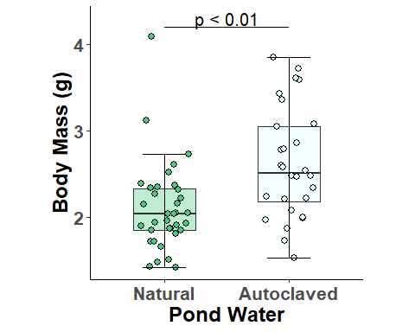

Figure for body mass values, although RMD compresses figures.

**GOSNER STAGE**

shapiro.test(df$Gosner_Stage)

##   
## Shapiro-Wilk normality test  
##   
## data: df$Gosner_Stage  
## W = 0.87649, p-value = 1.331e-05

Does not pass, likely because the values are so close together.

leveneTest(df$Gosner_Stage, df$Microbial_Trtmt, center = mean, na.rm = TRUE)

## Levene's Test for Homogeneity of Variance (center = mean: TRUE)  
## Df F value Pr(>F)  
## group 1 0.7153 0.401  
## 61

Passes, data is homoscedastic.

GosnerStage_glmm <- glmer(Gosner_Stage~Microbial_Trtmt + (1|Replicate),  
 data = df, family = "gaussian")

Anova(GosnerStage_glmm)

## Analysis of Deviance Table (Type II Wald chisquare tests)  
##   
## Response: Gosner_Stage  
## Chisq Df Pr(>Chisq)   
## Microbial_Trtmt 5.7942 1 0.01608 *  
## ---  
## Signif. codes: 0 '***' 0.001 '**' 0.01 '*' 0.05 '.' 0.1 ' ' 1

Found a significant effect of pond water treatment on Gosner Stage and subsequently development.

ggplot(df, aes(x= Microbial_Trtmt, y = Gosner_Stage, fill = Microbial_Trtmt)) +  
 geom_boxplot(width = 0.5, outlier.colour = "transparent", alpha =0.35) +  
 geom_jitter(width = .2, size = 2.5, shape = 21, color = "black") +  
 stat_boxplot(geom = "errorbar", width = .35) +  
 annotate(x = 1, xend = 2, y = 38, yend = 38, geom = "segment") +  
 annotate(x=1.5, y=38.2, label = "p < 0.05", geom = "text", size = 5.2) +  
 theme_classic() +  
 scale_fill_manual(values = c("seagreen2", "deepskyblue1")) +  
 labs(x = "Pond Water", y = "Gosner Stage (GS)") +  
 theme(aspect.ratio = 1) +  
 scale_x_discrete(labels = Pond_Water)+  
 theme(axis.text = element_text(face = "bold", size = 16)) +  
 theme(axis.title = element_text(face = "bold", size = 18)) +  
 theme(legend.position = "none")

## Warning: Removed 9 rows containing non-finite values (stat_boxplot).

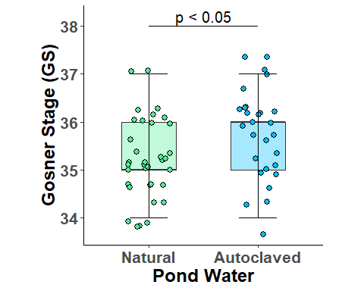

Data looks very similar. Looks like autoclaved tadpoles are heavier and also slightly more developed.

**PLASMA CORT**

shapiro.test(df$Corticosterone)

##   
## Shapiro-Wilk normality test  
##   
## data: df$Corticosterone  
## W = 0.68825, p-value = 1.352e-08

Looks like data is once again not normal.

leveneTest(df$Corticosterone, df$Microbial_Trtmt, center = mean, na.rm = TRUE)

## Levene's Test for Homogeneity of Variance (center = mean: TRUE)  
## Df F value Pr(>F)  
## group 1 0.5556 0.46  
## 44

Data is homoscedastic.

CORT_glmm <- glmer(Corticosterone~Microbial_Trtmt + (1|Replicate),  
 data = df, family = "gaussian")

Anova(CORT_glmm)

## Analysis of Deviance Table (Type II Wald chisquare tests)  
##   
## Response: Corticosterone  
## Chisq Df Pr(>Chisq)  
## Microbial_Trtmt 0.0163 1 0.8985

No effect of treatment on CORT which is interesting.

ggplot(df, aes(x= Microbial_Trtmt, y = Corticosterone, fill = Microbial_Trtmt)) +  
 geom_boxplot(width = 0.5, outlier.colour = "transparent", alpha =0.35) +  
 geom_jitter(width = .2, size = 2.5, shape = 21, color = "black") +  
 stat_boxplot(geom = "errorbar", width = .35) +  
 theme_classic() +  
 stat_boxplot(geom = "errorbar", width = .35) +  
 scale_fill_manual(values = c("seagreen3", "lightcyan")) +  
 labs(x = "Pond Water", y = "Plasma Corticosterone (ng/ml)") +  
 theme(aspect.ratio = 1) +  
 scale_x_discrete(labels = Pond_Water)+  
 theme(axis.text = element_text(face = "bold", size = 16)) +  
 theme(axis.title = element_text(face = "bold", size = 18)) +  
 theme(legend.position = "none")

## Warning: Removed 26 rows containing non-finite values (stat_boxplot).

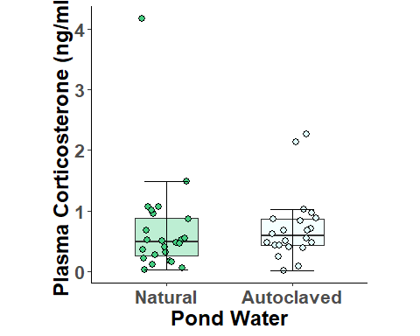

Not much difference, a couple outliers for both.